Perfect Pour Over Coffee

Cindy Ho

Mark Golla

Zeeshan Virani

**Functional System Requirements**

REVISION – Final

30 April 2022

Functional System Requirements

for

Perfect Pour Over Coffee

Prepared by:

_____________________________

Author Date

Approved by:

_____________________________

Mark Golla Date

_____________________________

John Lusher, P.E. Date

_____________________________

T/A Date

**Change Record**

| **Rev.** | **Date** | **Originator** | **Approvals** | **Description** |
| --- | --- | --- | --- | --- |
| **1** | 2/23/2022 | Mark Golla |  | Draft Release |
| **2** | 4/30/2022 | Mark Golla |  | Final Release |

**Table of Contents**

**Table of Contents 3**

**List of Tables 4**

**List of Figures 5**

1. **Introduction** **6**
   1. Purpose and Scope 6
   2. Responsibility and Change Authority 7
2. **Applicable and Reference Documents** **8**
   1. Applicable Documents 8
   2. Reference Documents 8
   3. Order of Precedence 8
3. **Requirements** **9**
   1. System Definition 9
   2. Characteristics 10
      1. Functional / Performance Requirements 10
         1. Application Data Size 10
         2. Maximum Brew Quantity 10
         3. Smartphone App Communication Range 11
      2. Physical Characteristics 11
      3. Electrical Characteristics 11
         1. Inputs 11
         2. Power Consumption 11
         3. Input Voltage Level 11
      4. Outputs 12
         1. Data Output 12
         2. Diagnostic Output 12
      5. Environmental Requirements 13
      6. Fault Detection 13
4. **Support Requirements** **14**
   1. Smartphone with Bluetooth Capabilities 14
   2. Maintenance 14
   3. Troubleshooting and Warranty14

**Appendix A: Acronyms and Abbreviations** **15**

**Appendix B: Definition of Terms** **16**

**List of Tables**

**Table** **1. Team Member Responsibilities** **7**

**Table** **2. Applicable Documents** **8**

**Table 3. Reference Documents 8**

**List of Figures**

**Figure 1. User Flowchart 6**

**Figure 2. Software Breakdown 9**

**Figure 3. Hardware Breakdown 9**

# 

# Introduction

## Purpose and Scope

The Perfect Pour Over Coffee System is meant to add automation and a high degree of precision to the brewing of pour over coffee in order to eliminate the error that occurs in a conventional brew. The device will be able to track the temperature of the water for brewing and add it in controlled intervals to keep the coffee grounds in the ideal saturation area. The device will also be able to change its brewing parameters based on the roast type of the grounds and user feedback on previous brews.

The sensor array for the device will include a water temperature sensor, multispectral camera, and a CO2 sensor. The water temperature sensor will ensure that the water being poured onto the grounds matches the recipe and the camera and CO2 sensor will work in tandem in order to determine the saturation of the grounds and whether it’s time to add another shower of water. The true saturation value is determined by a machine learning algorithm with the camera and CO2 sensor acting as inputs.

The device will use a database to store brewing parameters which can also be called recipes. These recipes will be updated after each brew in accordance with user feedback to try and tweak the recipe towards a better cup. The user will use an android app both to brew and provide feedback.

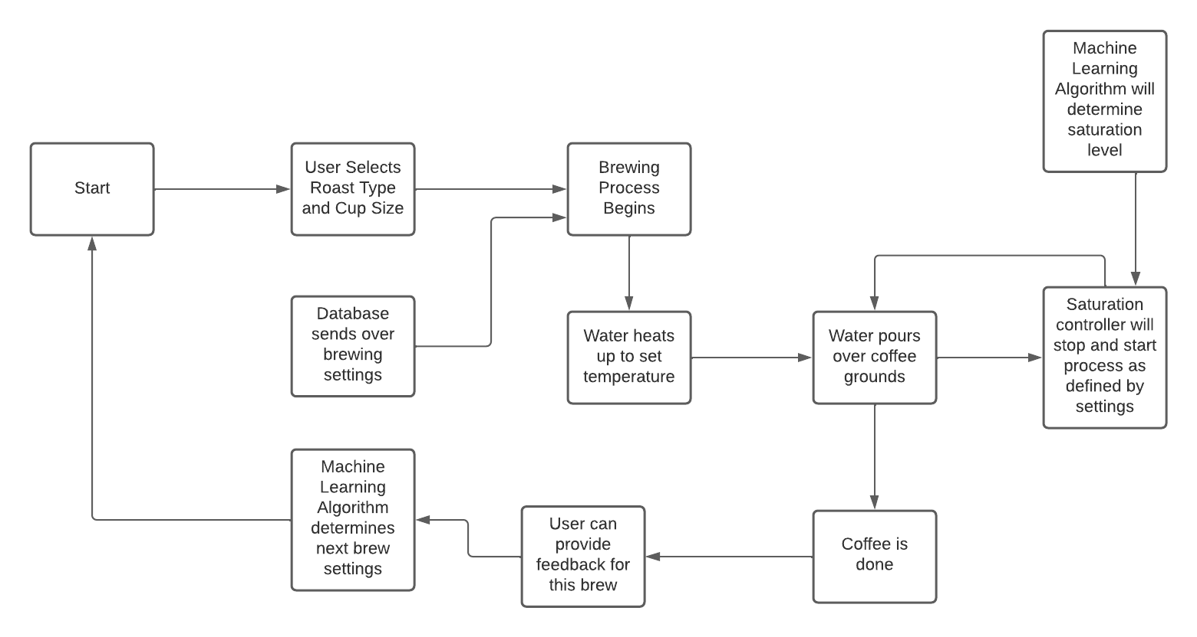

**Figure 1: User Flowchart**

## Responsibility and Change Authority

The team leader, Mark Golla, will be responsible for ensuring that the requirements are met. Mark will also have the authority to make the changes along with our sponsor, Stavros Kalafatis.

|  | Subsystem | Responsibilities |
| --- | --- | --- |
| Mark Golla | Hardware | Development of brewing hardware and control systems with associated sensors. |
| Cindy Ho | Database/ML | Creation of a database to house user data, preferences, brew history, and other relevant data  Training of a machine learning algorithm to determine saturation status of the grounds based on sensor input |
| Zeeshan Virani | Android Application | Development of an android application to control the device including a full UI, use guide, and user feedback system |

**Table 1: Team Member Responsibilities**

# Applicable and Reference Documents

## Applicable Documents

The following documents, of the exact issue and revision shown, form a part of this specification to the extent specified herein:

| **Document Number** | **Revision/Release Date** | **Document Title** |
| --- | --- | --- |
| Title 21 | 01/06/2022 | FDA - CFR Title 21 |
| UL 1082 | 09/29/2016 | Standard for electric coffee makers and brewing-type appliances |
| IEEE 802.15.1 | 2005 | WPAN / Bluetooth Communication Standards |
| IEC 60906-2 | 2011 | IEC system of plugs and socket-outlets for household |

**Table 2: Applicable Documents**

## Reference Documents

The following documents are reference documents utilized in the development of this specification. These documents do not form a part of this specification and are not controlled by their reference herein.

| **Document Title** | **Address** |
| --- | --- |
| Raspberry Pi 3B Documentation | <https://www.raspberrypi.com/documentation/computers/raspberry-pi.html> |
| Raspberry Pi Camera v2 Documentation | <https://www.raspberrypi.com/documentation/accessories/camera.html> |
| DS18B20 | <https://datasheets.maximintegrated.com/en/ds/DS18B20.pdf> |

**Table 3: Reference Documents**

## Order of Precedence

In the event of a conflict between the text of this specification and an applicable document cited herein, the text of this specification takes precedence without any exceptions.

All specifications, standards, exhibits, drawings or other documents that are invoked as “applicable” in this specification are incorporated as cited. All documents that are referred to within an applicable report are considered to be for guidance and information only, except ICDs that have their relevant documents considered to be incorporated as cited.

# Requirements

## System Definition

The Perfect Pour Over Coffee system is a coffee brewing machine which heats and pours water over coffee grounds in order to produce coffee. The device will use a machine learning powered array of sensors to track the brewing process and ensure that the brew meets certain parameters such as water temperature and ground saturation. The device will be controlled through the use of an android smartphone application which will allow the user to select the amount and type of coffee before brewing as well as rate the result afterwards. The resultant rating is used to change or reinforce the parameters for future brews.

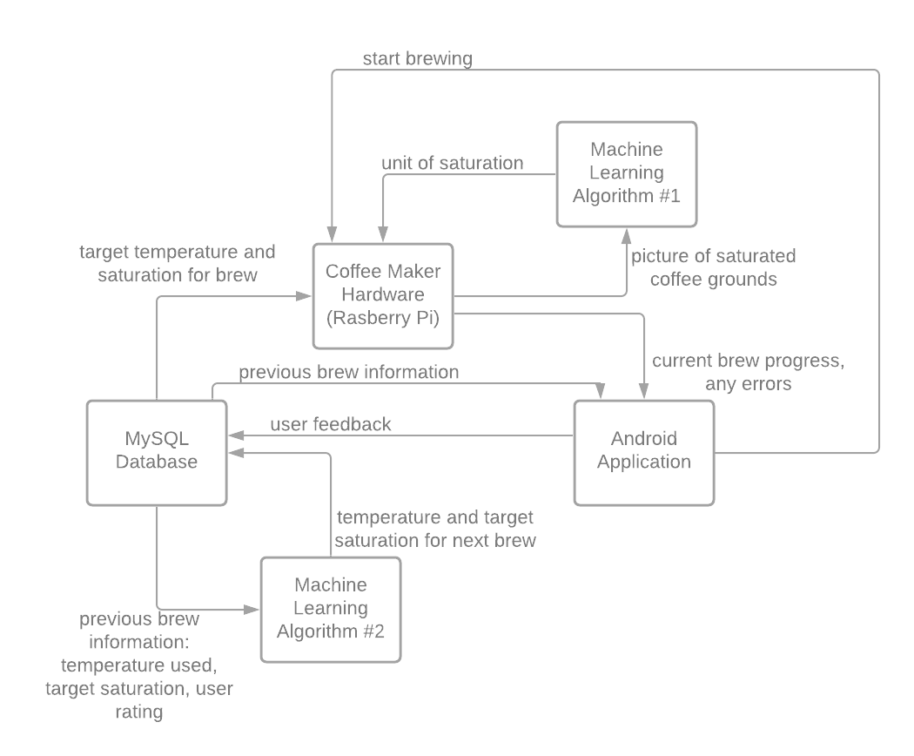

**Figure 2. Software Conceptual Breakdown**



**Figure 3. Hardware Conceptual Breakdown**

Brewing Hardware: The brewing hardware will first heat its reservoir of water until it reaches the brewing parameter and work to maintain this temperature throughout the brewing process. The water will be dispersed using a sprinkler system above the grounds and will continue adding water periodically through a valve actuation depending on the sensor array’s reading of the grounds’ status.

Sensor Array: A temperature sensor will be implemented into the water reservoir to track the temperature of the water before its poured into the grounds. The temperature read will determine how much power is supplied to the heating element. To monitor the grounds and determine whether more water should be added, a combination of a CO2 sensor and a multispectral camera will be placed above the grounds. The values read from these sensors will be fed to a machine learning algorithm to determine a saturation value and whether the grounds can absorb any more water.

Power: A converter will be implemented to convert 120 VAC to 5 VDC at no more than 2.5 amps for use with the pi, sensor array, and water distribution valve. A 120 VAC line also will be modulated according to the pi in order to provide controlled power to the heating element

Machine Learning Algorithm #1: First, a training dataset will be created for the algorithm. The dataset will consist of images of ground beans at various levels of saturation for the four types of roast. Since the images will be taken by a multispectral imaging camera, there will be an image for each wavelength. The algorithm will then take the average red pixel value since the blue and green won’t pick up the NIR. These averages correlate to the water content of the grounds since water has different absorbancy in NIR than coffee grounds. The algorithm itself will be created in Python and contain libraries from TensorFlow. The end result will be a linear classification model to predict the saturation level. Once the algorithm has been trained with the initial dataset, there will be at least two more testing datasets to validate the model. After the model is verified, it will be implemented and the desired saturation levels will be saved into the database.

Android Application: This subsystem will handle the user interface and interaction with the hardware. The user will be able to select their coffee roast type and the quantity to dispense then be able to start the brewing process. The user also will have access to brewing history and the ability to rate previous brews. The rating process will be used to determine the parameters for the next brewing session. The app will also provide some basic hardware information as well as how to maintain the device and troubleshoot any issues they may encounter. The application will connect to the Raspberry Pi and a MySQL Database.

Machine Learning Algorithm #2: This algorithm will be responsible for matching preferences according to a user’s feedback through the utilization of K-Nearest Neighbors, a statistical classifier model. When negative feedback is received, the script will use that feedback to adjust preferences such as strength, grind size, target temperature, and target water volume. On the other hand, the script will continue matching the preferences to the user if positive feedback is received. If there is a new user, the chosen temperature will then be picked based upon the average temperature that corresponds with the positive feedback.

Firebase Database: The database will handle storing and managing all the data. The data includes login information, brewing sessions, and user settings. The database will provide this data to the android application as well as one machine learning algorithm that will compute brewing parameters for a user’s next brew. The database will also be available through the cloud.

## Characteristics

### Functional / Performance Requirements

#### Application Data Size

The Android application will not exceed 15 megabytes of storage.

*Rationale: This will allow users to be able to quickly download the application and will not be a burden to most people’s storage capacity.*

#### Maximum Brew Quantity

The amount of coffee that can be brewed at one time will not exceed 24 oz

*Rationale: 24 oz is the size of the carafe and the user shouldn’t be able to brew more than it can hold*

#### Smartphone App Communication Range

The smartphone being used to control brewing should be within 30 ft of the device

*Rationale: 30 ft is the functional range for bluetooth*

### Physical Characteristics

The volume envelope of the Perfect Pour Over Coffee System will be less than or equal to 48x48x48 inches . It will also need to accommodate a carafe that is 11 in tall and 6 inches in diameter beneath the brewing hardware.

*Rationale: The device is expected to be reasonably small to fit onto a kitchen counter alongside other appliances and house a carafe within it*

### Thermal Characteristics

The water reservoir should be able to be heated to any temperature between 185- 205 F and stay within 2 degrees.

*Rationale: This is a range of common temperature that could be used for brewing*

### Electrical Characteristics

#### Inputs

The presence or absence of any combination of the input signals in accordance with ICD specifications applied in any sequence shall not damage the Perfect Pour Over Coffee System, reduce its life expectancy, or cause any malfunction, either when the unit is powered or when it is not.

No sequence of command shall damage the Perfect Pour Over Coffee System, reduce its life expectancy, or cause any malfunction.

*Rationale: By design, should limit the chance of damage or malfunction by user error.*

##### Power Consumption

The maximum peak power of the system shall not exceed 1500 watts.

*Rationale: Most kettles are 1500 watts. This is because although wall outlets are usually rated for 15 amps, appliances shouldn’t pull this full current since the breaker is likely to trip.*

##### Input Voltage Level

The input voltage level for the system will be 120 VAC. This voltage will be converted to 5V DC for the Pi, sensor array, and water flow servo. The 120V will be applied to the heating element with a current limiting resistor and pulse width modulation. The 5V supply may not exceed 5.25 V or drop below 4.75 V

*Rationale: The device is expected to be located in a kitchen and will need to be powered by a conventional 120 V wall socket. The control circuitry runs on 5V, but the heating element will need more power to quickly heat water, which is more easily achieved at 120 V. The Raspberry Pi has built in 5V regulators, so ripple isn’t a concern, but the voltage must remain between 4.75 and 5 Volts*

#### Outputs

##### Data Output

The Raspberry Pi will output brewing process status directly to the user’s android smartphone.

*Rationale: The user is able to monitor at what point of the brewing process their coffee is in as well as be able to see if any issues occur.*

##### Diagnostic Output

The Perfect Pour Over Coffee System will have a LAN port located on the pi which can be used to ssh in and run basic diagnostics or reinstall the brewing software

*Rationale: Provides the ability to access the hardware directly for debugging manually and a way to update the software*

### Environmental Requirements

The Perfect Pour Over Coffee System will be designed for indoor use only and will be designed to operate in standard indoor climate conditions of 50 to 90 degrees fahrenheit and humidity of 0 to 50%. While the device will be designed to handle moisture from brewing condensation and cleaning, it may not be submerged.

*Rationale: The device is meant for a kitchen environment, but is not required to be waterproof.*

### Fault Detection

The Perfect Pour Over Coffee System will arrest overheating scenarios through the use of a thermal fuse. Once the unit reaches the unsafe operating temperature threshold of 150C, the switch will flip, disabling the unit. A 13 amp electrical fuse will also be added to protect the user and device in the event of water leakage, grounding fault, or other electrical abnormality.

The device will also protect against user error by ensuring there is a carafe present to receive the coffee as well as a sensor to detect that there is water remaining in the reservoir. Should a user error occur, they will be alerted through the app as well as the blinking of the power indicator light.

# Support Requirements

**4.1 Smartphone with Bluetooth Capabilities**

The advanced features of this device, including the ability to adjust settings based on user input, will require the customer to be able to use an Android smartphone with bluetooth capabilities to connect to the device.

**4.1 Maintenance**

The user will be required to clean and maintain the device using instructions from the user manual featured in the android smartphone application.

**4.1 Troubleshooting and Warranty**

For issues that are beyond user control, the user is able to email the customer support team for assistance. If the issue is beyond repair virtually, the user may send the device back for repairs under the included manufacturer warranty coverage.

# Appendix A: Acronyms and Abbreviations

BIT Built-In Test

I2C Inter-Integrated Circuit

CSI Camera Serial Interface

GPIO General-Purpose Input/Output

VAC Volts (Alternating Current)

VDC Volts (Direct Current)

V Volts

A Amps

LAN Local Area Network

ML Machine Learning

Pi Raspberry Pi

CO2 Carbon Dioxide

NIR Near-Infrared